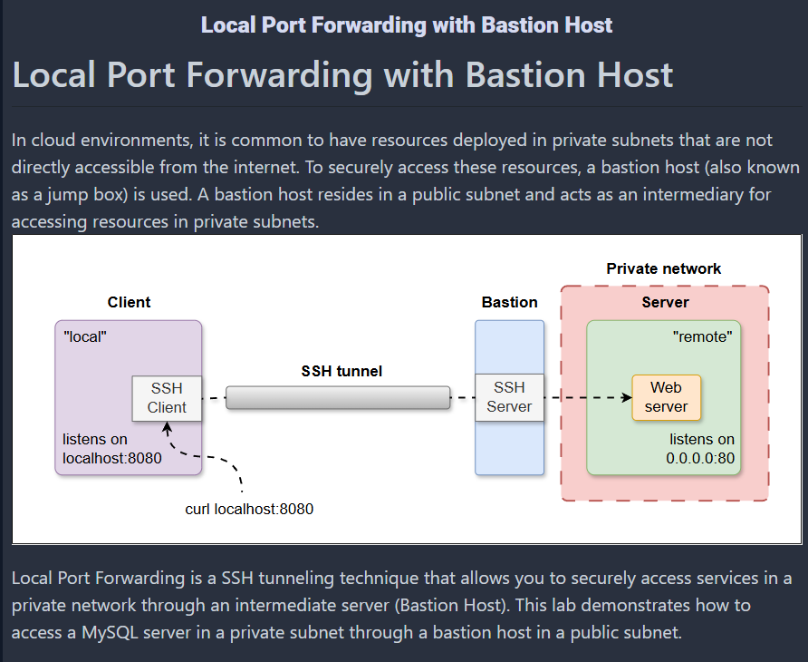

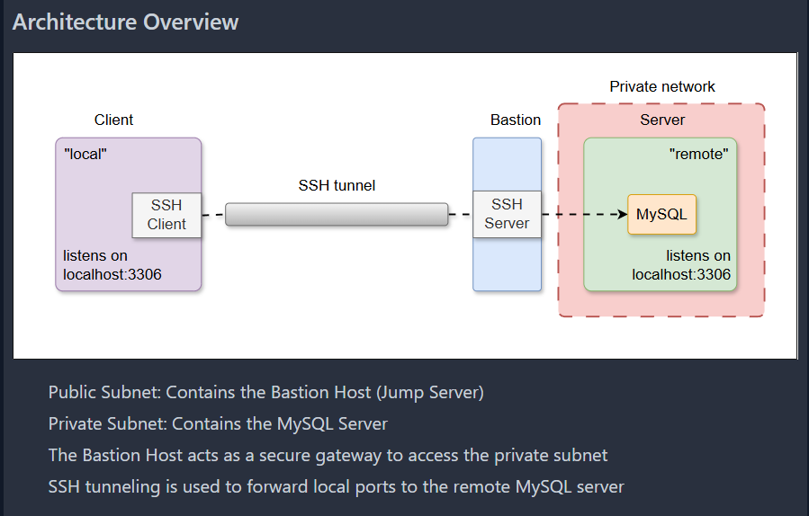

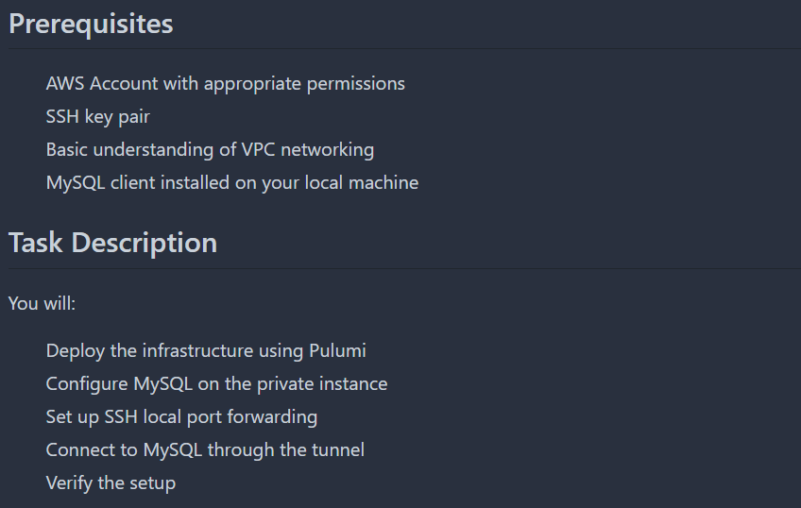

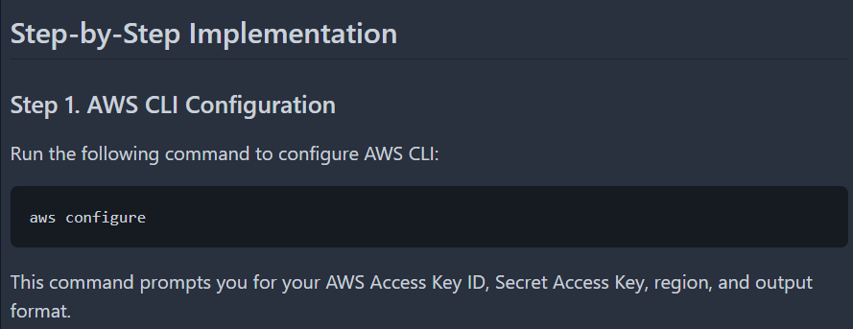

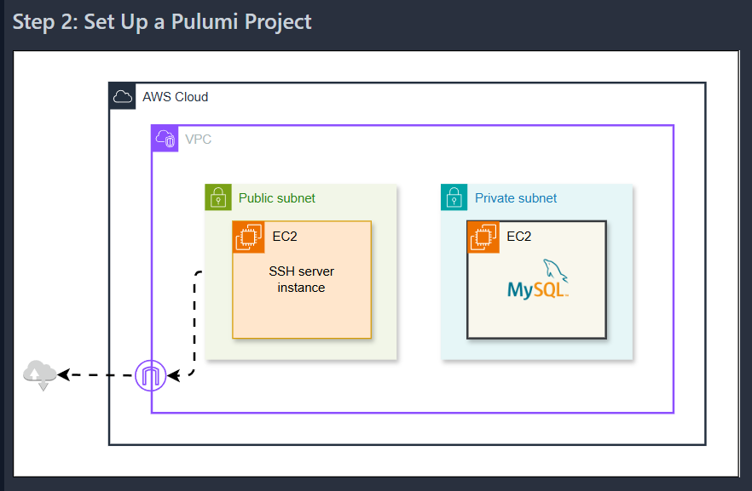

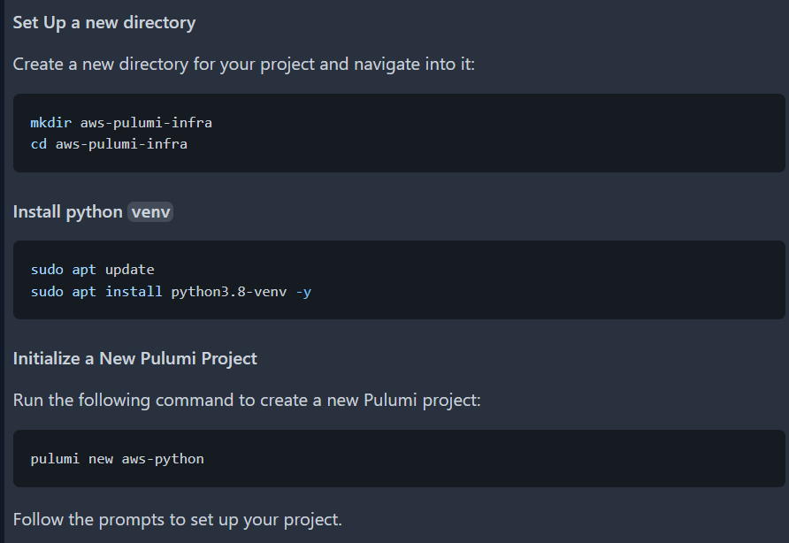

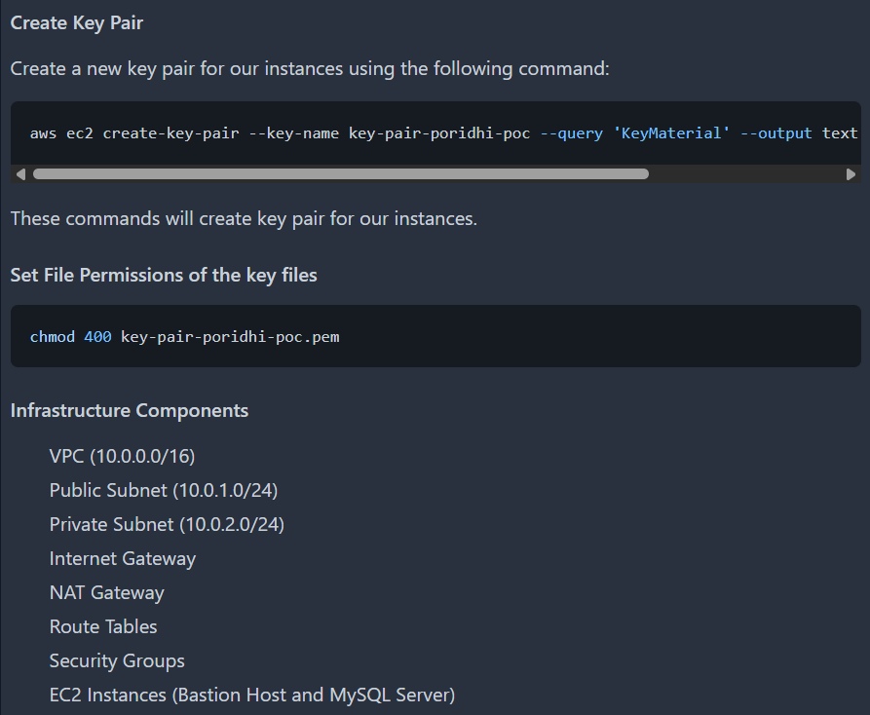

aws ec2 create-key-pair --key-name key-pair-poridhi-poc --query 'KeyMaterial' --output text > key-pair-poridhi-poc.pem



import pulumi

import pulumi_aws as aws

# Create a VPC

vpc = aws.ec2.Vpc("my-vpc",

cidr_block="10.0.0.0/16",

enable_dns_support=True,

enable_dns_hostnames=True

)

# Create an Internet Gateway

internet_gateway = aws.ec2.InternetGateway("my-igw",

vpc_id=vpc.id

)

# Create a Public Subnet

public_subnet = aws.ec2.Subnet("public-subnet",

vpc_id=vpc.id,

cidr_block="10.0.1.0/24",

map_public_ip_on_launch=True

)

# Create a Private Subnet

private_subnet = aws.ec2.Subnet("private-subnet",

vpc_id=vpc.id,

cidr_block="10.0.2.0/24",

map_public_ip_on_launch=False

)

# Create a Route Table for the Public Subnet

public_route_table = aws.ec2.RouteTable("public-route-table",

vpc_id=vpc.id,

routes=[aws.ec2.RouteTableRouteArgs(

cidr_block="0.0.0.0/0",

gateway_id=internet_gateway.id,

)]

)

# Associate the Public Subnet with the Public Route Table

public_route_table_association = aws.ec2.RouteTableAssociation("public-route-table-association",

subnet_id=public_subnet.id,

route_table_id=public_route_table.id

)

# Create a route table for the private subnet

private_route_table = aws.ec2.RouteTable("private-route-table",

vpc_id=vpc.id,

tags={

"Name": "my-private-route-table"

}

)

# Allocate an Elastic IP for the NAT Gateway

eip = aws.ec2.Eip("nat-eip", vpc=True)

# Create the NAT Gateway

nat_gateway = aws.ec2.NatGateway("nat-gateway",

subnet_id=public_subnet.id,

allocation_id=eip.id,

tags={

"Name": "my-nat-gateway"

}

)

# Create a route in the route table for the NAT Gateway

private_route = aws.ec2.Route("nat-route",

route_table_id=private_route_table.id,

destination_cidr_block="0.0.0.0/0",

nat_gateway_id=nat_gateway.id

)

# Associate the route table with the private subnet

private_route_table_association = aws.ec2.RouteTableAssociation("private-route-table-association",

subnet_id=private_subnet.id,

route_table_id=private_route_table.id

)

# Create a Security Group for the Bastion Host

bastion_sg = aws.ec2.SecurityGroup("bastion-sg",

vpc_id=vpc.id,

description="Allow SSH from all IPs",

ingress=[

aws.ec2.SecurityGroupIngressArgs(

protocol="tcp",

from_port=22,

to_port=22,

cidr_blocks=["0.0.0.0/0"], # Allow SSH from anywhere

),

],

egress=[

aws.ec2.SecurityGroupEgressArgs(

protocol="-1",

from_port=0,

to_port=0,

cidr_blocks=["0.0.0.0/0"], # Allow all outbound traffic

),

],

)

# Create a Security Group for the MySQL Server

mysql_sg = aws.ec2.SecurityGroup("mysql-sg",

vpc_id=vpc.id,

description="Allow SSH from Bastion Host and MySQL from Bastion Host",

ingress=[

# Allow SSH from the Bastion Host

aws.ec2.SecurityGroupIngressArgs(

protocol="tcp",

from_port=22,

to_port=22,

security_groups=[bastion_sg.id], # Restrict SSH to the Bastion Host

),

# Allow MySQL from the Bastion Host

aws.ec2.SecurityGroupIngressArgs(

protocol="tcp",

from_port=3306,

to_port=3306,

security_groups=[bastion_sg.id], # Restrict MySQL to the Bastion Host

),

],

egress=[

aws.ec2.SecurityGroupEgressArgs(

protocol="-1",

from_port=0,

to_port=0,

cidr_blocks=["0.0.0.0/0"], # Allow all outbound traffic

),

],

)

# Create the Bastion Host in the Public Subnet

bastion_host = aws.ec2.Instance("bastion-host",

instance_type="t2.micro",

ami="ami-0672fd5b9210aa093", # Replace with your desired AMI ID

vpc_security_group_ids=[bastion_sg.id],

subnet_id=public_subnet.id,

key_name="key-pair-poridhi-poc", # Replace with your key pair name

tags={

"Name": "bastion-host",

}

)

# Create the MySQL Server in the Private Subnet

mysql_server = aws.ec2.Instance("mysql-server",

instance_type="t2.micro",

ami="ami-0672fd5b9210aa093", # Replace with your desired AMI ID

vpc_security_group_ids=[mysql_sg.id],

subnet_id=private_subnet.id,

key_name="key-pair-poridhi-poc", # Replace with your key pair name

tags={

"Name": "mysql-server",

}

)

# Output the Public IP of the Bastion Host

pulumi.export("bastion_host_public_ip", bastion_host.public_ip)

# Output the Private IP of the MySQL Server

pulumi.export("mysql_server_private_ip", mysql_server.private_ip)

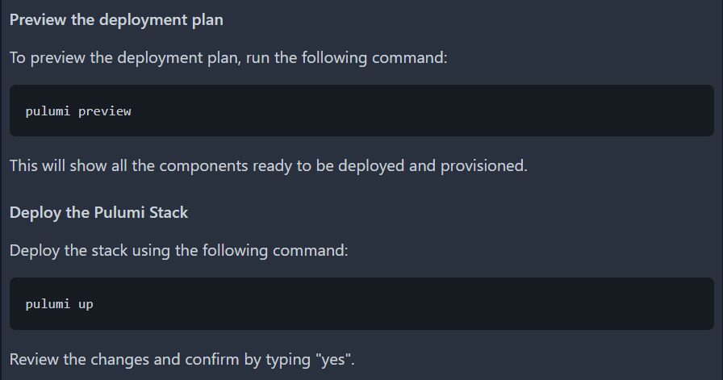

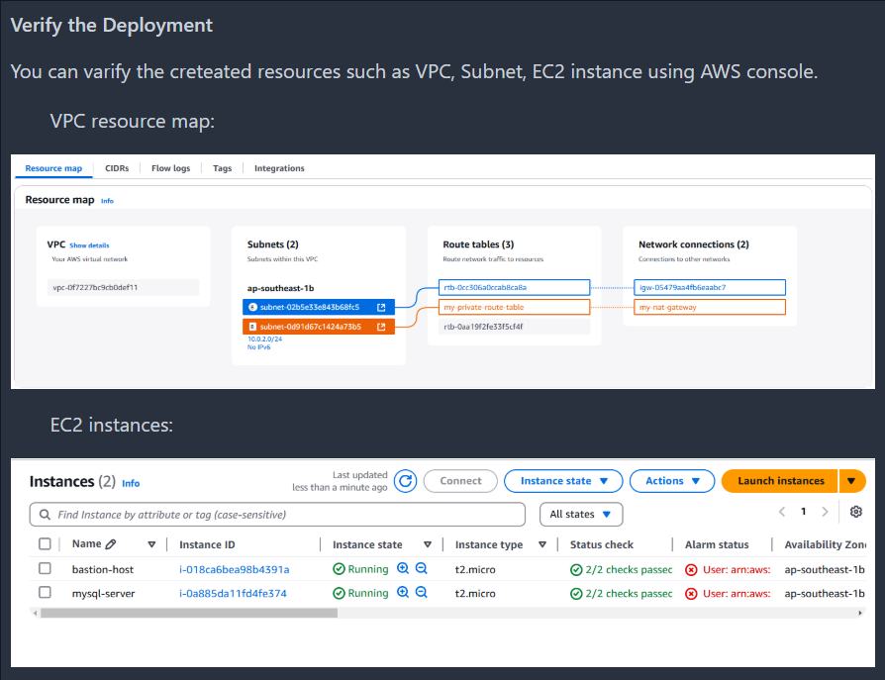

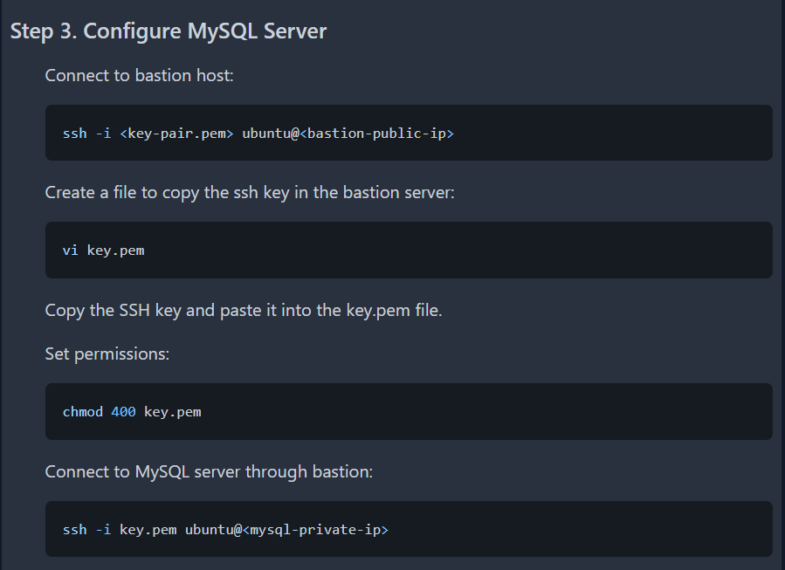

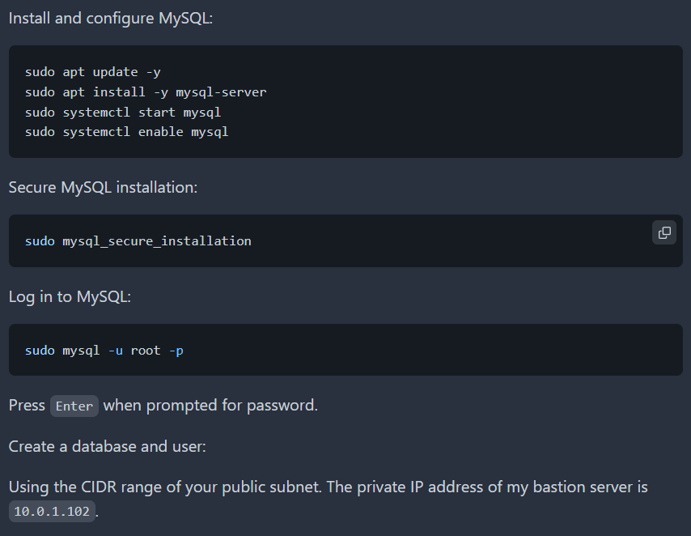

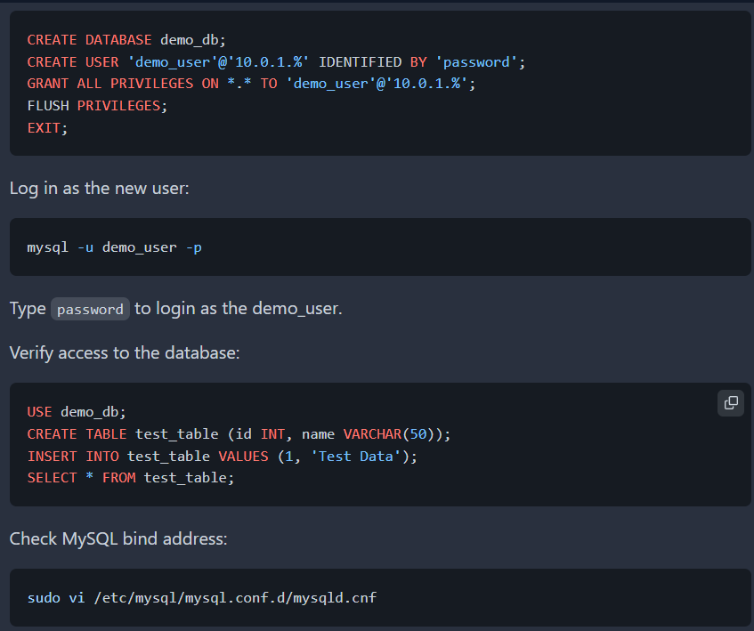

CREATE DATABASE demo_db;

CREATE USER 'demo_user'@'10.0.1.%' IDENTIFIED BY 'password';

GRANT ALL PRIVILEGES ON *.* TO 'demo_user'@'10.0.1.%';

FLUSH PRIVILEGES;

EXIT;

CREATE USER 'demo_user'@'localhost' IDENTIFIED BY 'password';

GRANT ALL PRIVILEGES ON *.* TO 'demo_user'@'localhost';

FLUSH PRIVILEGES;

USE demo_db;

CREATE TABLE test_table (id INT, name VARCHAR(50));

INSERT INTO test_table VALUES (1, 'Test Data');

SELECT * FROM test_table;

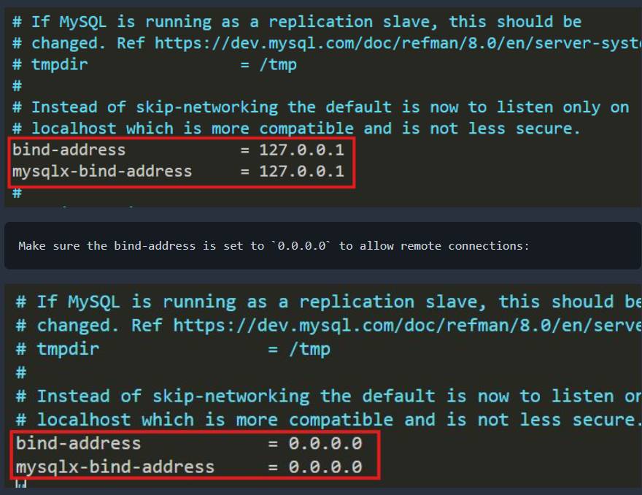

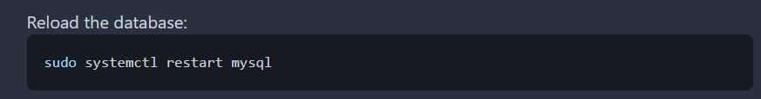

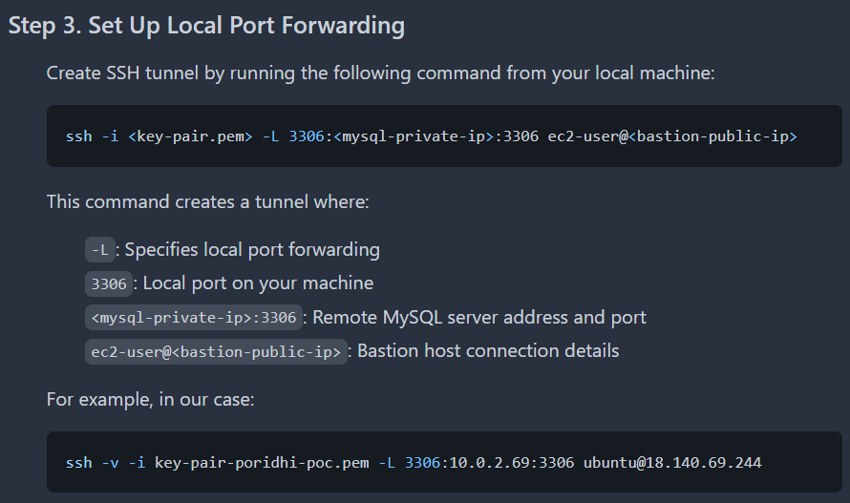

ssh -i <key-pair.pem> -L 3306:<mysql-private-ip>:3306 ec2-user@<bastion-public-ip>

ssh -f -N -i <key-pair.pem> -L 3306:<mysql-private-ip>:3306 ec2-user@<bastion-public-ip> [For running in Background]

How it works

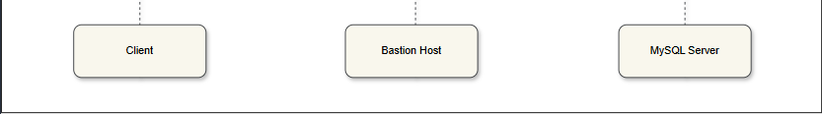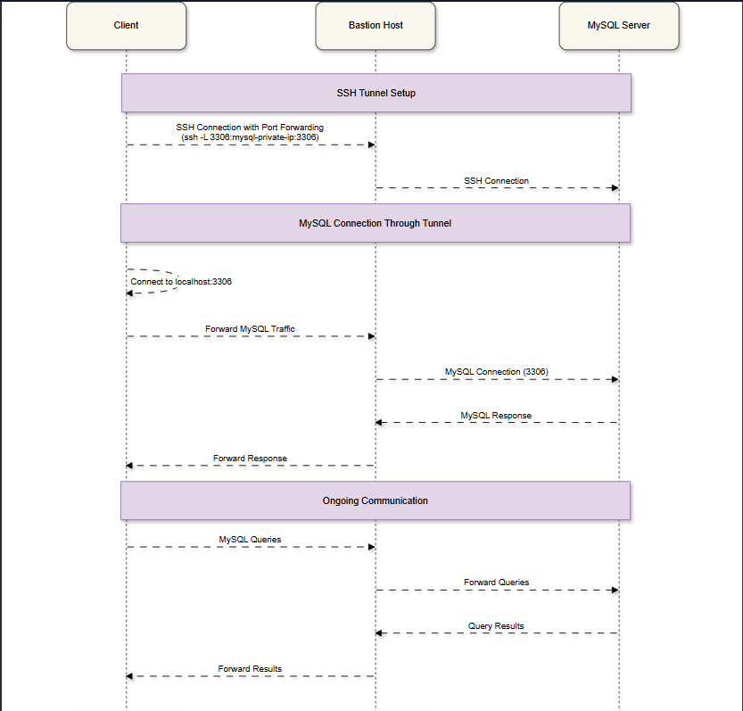

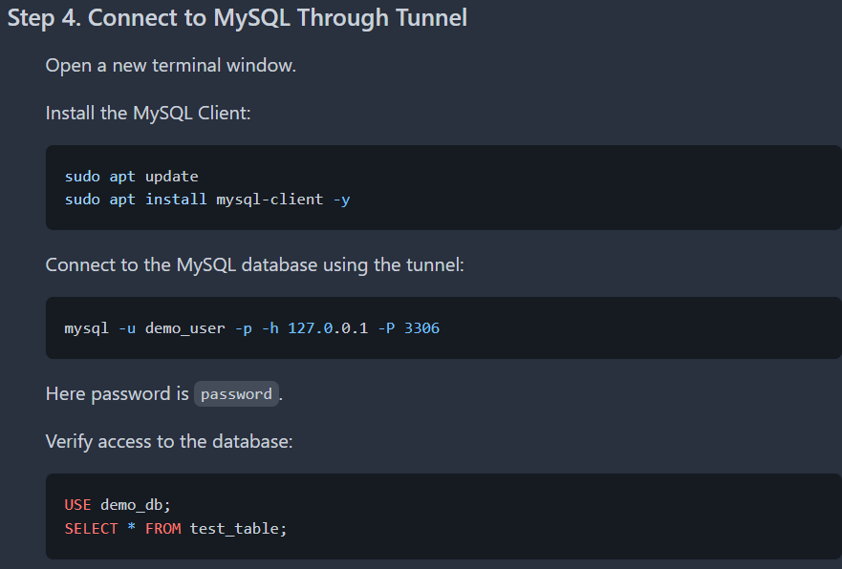

mysql -u demo_user -p -h 127.0.0.1 -P 3306

